CITY OF SHEBOYGAN HOUSING AUTHORITY APPLICATION
611 N. WATER ST., P.O. BOX 1052, SHEBOYGAN, WI 53082-1052
920-459-3466
__________________________________________________________________________________

INSTRUCTIONS FOR COMPLETING YOUR APPLICATION

1. Fill out entire application in ink pen. You must complete the entire application, including
social security numbers for all household members who have them, dates of birth, and a
mailing address. Incomplete applications or applications filled out in pencil will be returned.

2. Read the descriptions of the priorities and check those that apply to you.

6. All applicants will be contacted by mail and notified when their name comes near the top of the list. If you move, please contact us with your new address.

You may drop off
Your application between 8:00 a.m. - 4:30 p.m. or mail it to the address listed above.

EQUAL OPPORTUNITY HOUSING

02/13/13
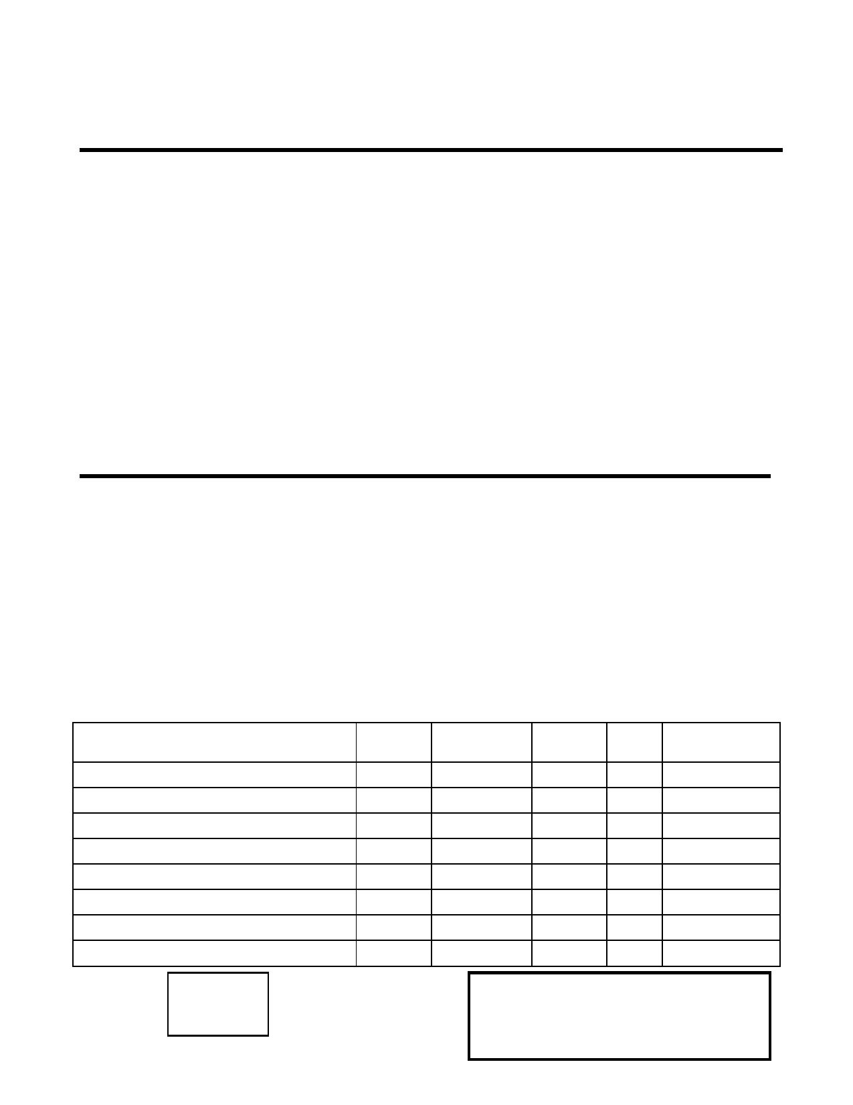
SHEBOYGAN HOUSING AUTHORITY APPLICATION
Please mark all waiting lists you wish to apply for:

Public Housing - Public Housing are apartments and houses owned by the Housing Authority that we
rent to tenants for approximately 30% of their gross income. These are located in
various parts of Sheboygan. Georgia Avenue units with 2 or 3 bedrooms are available to families with minor children.

____ Wasserman Building
____ Tamarack House
____ Park Plaza
____ Georgia Avenue (Family Units)

______Section 8 - The Housing Authority pays a portion of the rent tenants pay approximately 30% of their gross income for their portion of the rent. Participants are responsible for finding their own unit.

HEAD OF HOUSEHOLD INFORMATION

Name: __________________________________________ Social Security # __________________
(Last) (First) (Middle)

Birthdate__________ Sex _____ Age ___Street Address __________________________Apt #__

City: _______________________ State: _______ Zip Code: __________ Phone # ______________

Mailing Address (If different from above): ______________________________________________

List all other family members:
Birth Relationship Sex Age Social
Security #
First Middle Last Date M/F

Bedroom
Date/time stamp
Size:
02/13/13
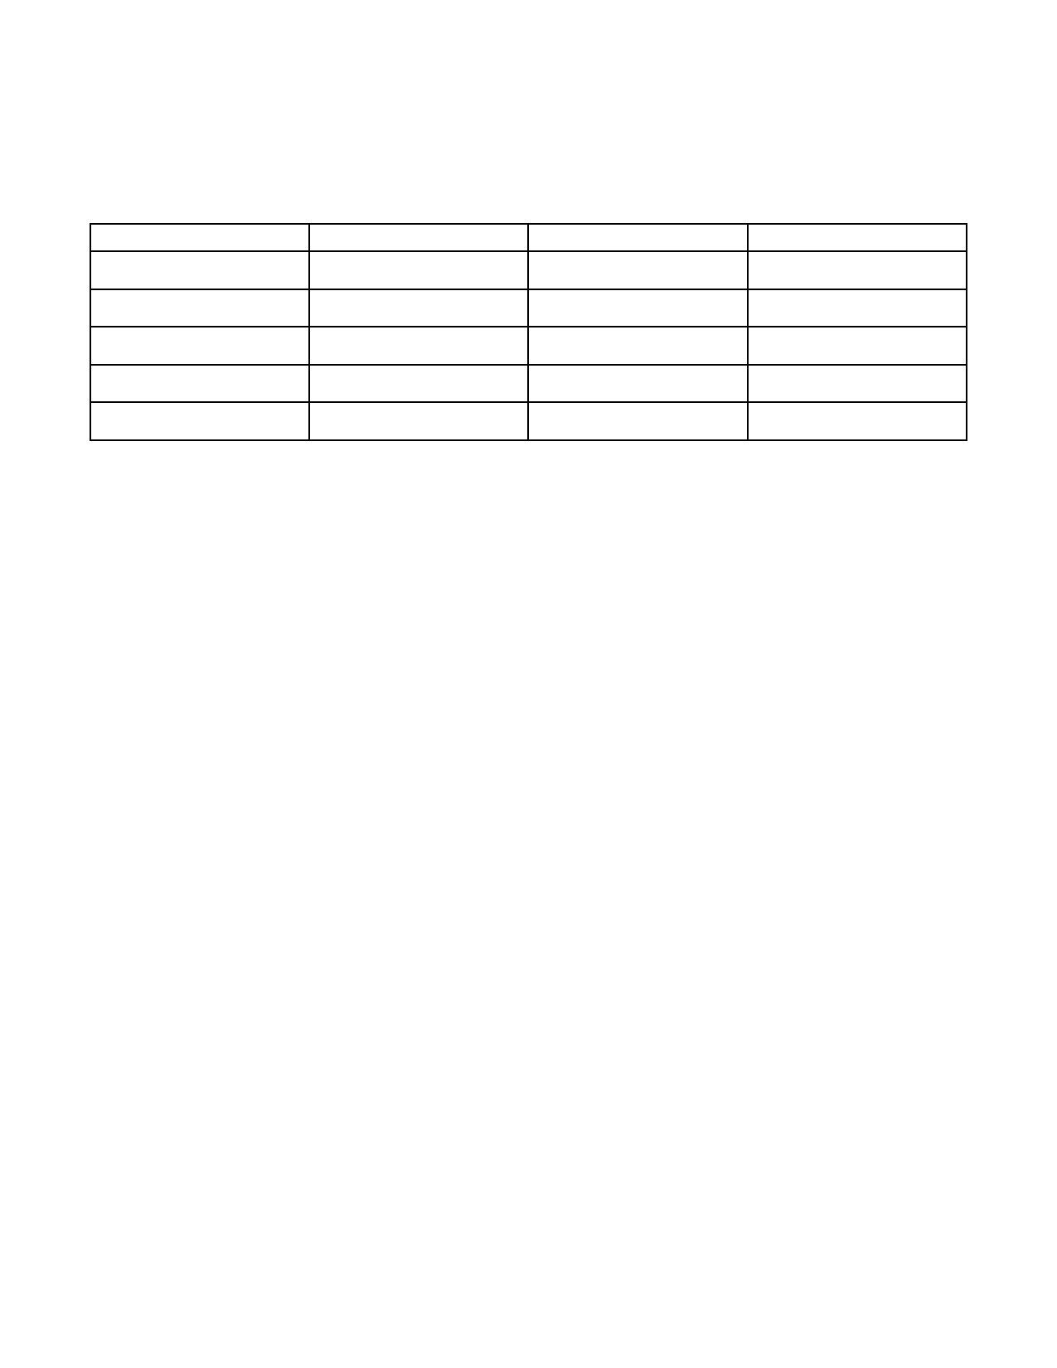
INCOME

List all sources of income including employment, cash income, W-2, social security, SSI, disability or unemployment compensation, alimony, child support, etc. This includes income you receive for a child
such as SSI, food stamps, etc. IF someone is helping you with monthly expenses, food, utilities, car payments or other cash payments, you must list it below.

Family Member Source of Income Amount Received How Often

List all assets and asset value for your household:
Savings Account $_______ Checking Account $____________ Real Estate $__________ Cash on Hand $______
Certificate of Deposit $_________ Stamp/Coin Collection $_________ Collector Cars_________

Friend or Relative you want us to notify in case of emergency.

Name____________________________ Relationship_____________Telephone______________

PRIORITY QUALIFICATION: Check as many as apply.

_____ Displaced by federal, state, or local declared disaster within the last 6 months. Government
disaster documentation required.

_____ Sheboygan Resident for 6 months or longer: You LIVE, WORK or attend SCHOOL within
the city limits of Sheboygan, Wisconsin. Verification showing where you live, work or attend
school is required at time of interview

_____ Handicapped accessible UNIT required: Check here if you need a unit with handicapped
fitted restrooms, wider doorways, no stairs, and a ramp. Verification by a medical
professional is required.

_____ Participant in program for victims of Domestic Violence Verification by a DV program
director is required AND documentation of a pattern of abuse within the last 6 months.
Verification must include one of the following: police reports, hospital records, counselor records, or HUD-50066 form. Verification required at time of application.

_____ Currently Homeless.

02/13/13
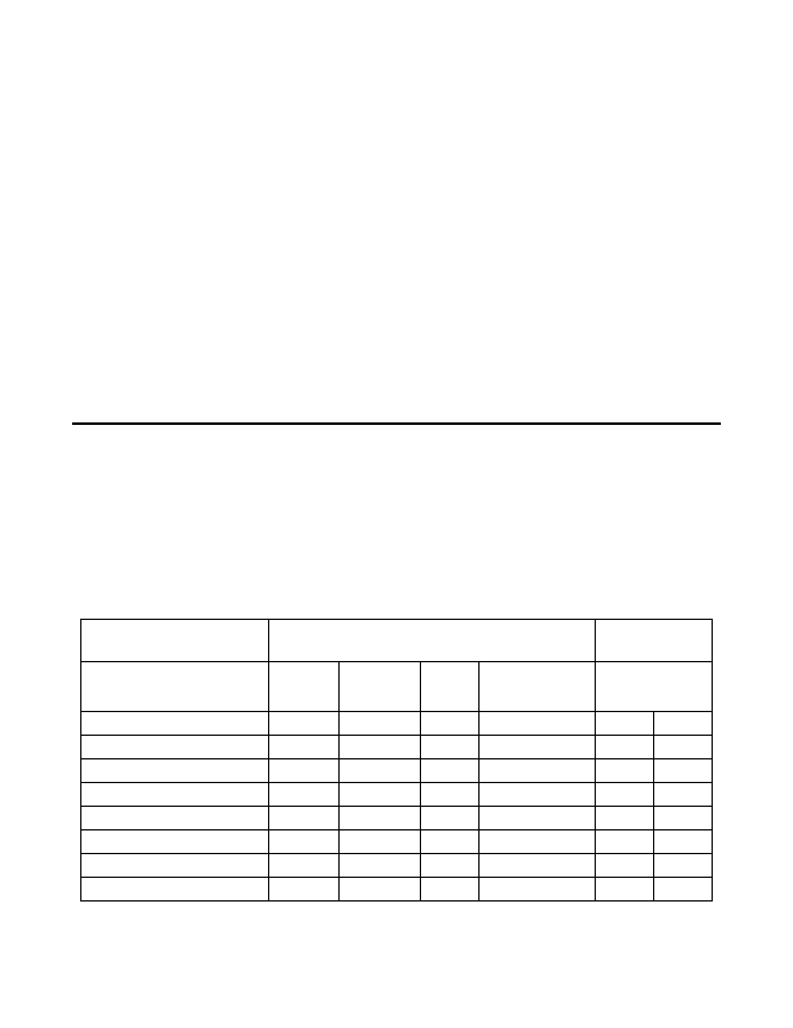
PROGRAM INFORMATION:
Have you ever participated in a rental assistance or public housing program? __________ If yes, where and when did you participate? _____________________________________

History of Applicant/Co-Applicants:
Have you or any household member over seventeen years old ever been convicted of a crime other than a traffic ticket? ____ Yes _____ No
If yes, List here. _______________________________________________
(If you run out of space use notebook paper and attach with application.)
Maiden name or other names used by any members of the household ______________________ Are any members of your household handicapped or disabled? ___________ If so who _______

ALL APPLICATION INFORMATION IS TRUE AND COMPLETE TO THE BEST OF MY KNOWLEDGE.
WARNING: Section 1001 of Title 18 of the U.S. Code makes it a criminal offense to make willful false statements of misrepresentation to any Department of Agency of the United States as to any matter within its jurisdiction.

Signature: Date:

RACIAL GROUP INDENTIFICATION: The following information is required for statistical purposes so the Department of Housing and Urban Development may determine the degree to which minority families utilize its programs. The categories have been defined by HUD. Hispanic is defined as an ethnicity; races are defined as White, Black/African American, Asian, and Native Hawaiian/Pacific Islander.

Check ALL races that apply to each person in your household.
Circle Yes or No to identify if each person in your household is Hispanic.

List family members,
Including yourself

Race
Check all that apply

Ethnicity
Circle one

Name

White
African
American

Asian
Native Hawaiian/
Pacific Islander
Is this person also
Hispanic?

YES
YES
YES
YES YES YES
YES

NO
NO
NO
NO NO NO
NO

02/13/13

